SOFTWARE REQUIREMENTS SPECIFICATION

**For**

**TASK MANAGEMENT SYSTEM**

**Prepared by:-**

Intelligence Hub

# Introduction

## Purpose

The primary purpose of this document is to outline the objectives and requirements for the development of a Task Management System (TMS). The TMS is designed to streamline and enhance task-related activities for individuals or teams within an organization. This document provides a comprehensive overview of both functional and non-functional requirements, ensuring a clear understanding of the project's scope and expectations.

## Document Conventions

* + - Entire document should be justified.
    - Convention for Main title

Font face: Times New Roman Font style: Bold

Font Size: 14

* + - Convention for Sub title

Font face: Times New Roman Font style: Bold

Font Size: 12

* + - Convention for body

Font face: Times New Roman Font Size: 12

## Scope of Development Project

The scope of the Task Management System (TMS) development venture encompasses the introduction of an internet-based totally platform designed to streamline project control strategies within an corporation. Core capabilities encompass robust consumer authentication with position-primarily based get entry to manipulate, challenge introduction and mission functionalities permitting customers to specify information such as title, description, due date, precedence, and assignee. Real-time task tracking and personalized user dashboards will provide visibility into challenge status, upcoming cut-off dates, and ordinary productivity. Additional functions incorporate team collaboration equipment, reporting and analytic capabilities with export capability, a notification system for assignment updates, and get entry to manage to restrict functionalities based on user roles.

Non-useful necessities dictate most fulfilling overall performance, stringent safety features, reliable backup mechanisms, and a person-pleasant interface. The assignment is restrained via compatibility with modern internet browsers, adherence to budgetary constraints, and adherence to precise timelines. Dependencies consist of integration with the organization's person authentication machine and the usage of external libraries or frameworks. Exclusions from the venture scope involve integration with unspecified 1/3-party programs and the improvement of cellular packages unless explicitly agreed upon. The report serves as a comprehensive guide, situation to stakeholder overview and approval earlier than assignment initiation.

## Definitions, Acronyms and Abbreviations

JAVA -> platform independence SQL> Structured query Language ER-> Entity Relationship

UML -> Unified Modeling Language

IDE> Integrated Development Environment SRS-> Software Requirement Specification

TMS-> Task Management System

## References

* + - Books

 Task Management System(TMS) for University of Malaya Research Student by Loav Alabid

* + - Website:
* **<https://WWW.researchgate.net/publication/>313029638_Task_Management_System_TMS_for_University_of_Malaya_Research_Student.**

# Overall Descriptions

## Product Perspective

Use Case Diagram of Task Management system.

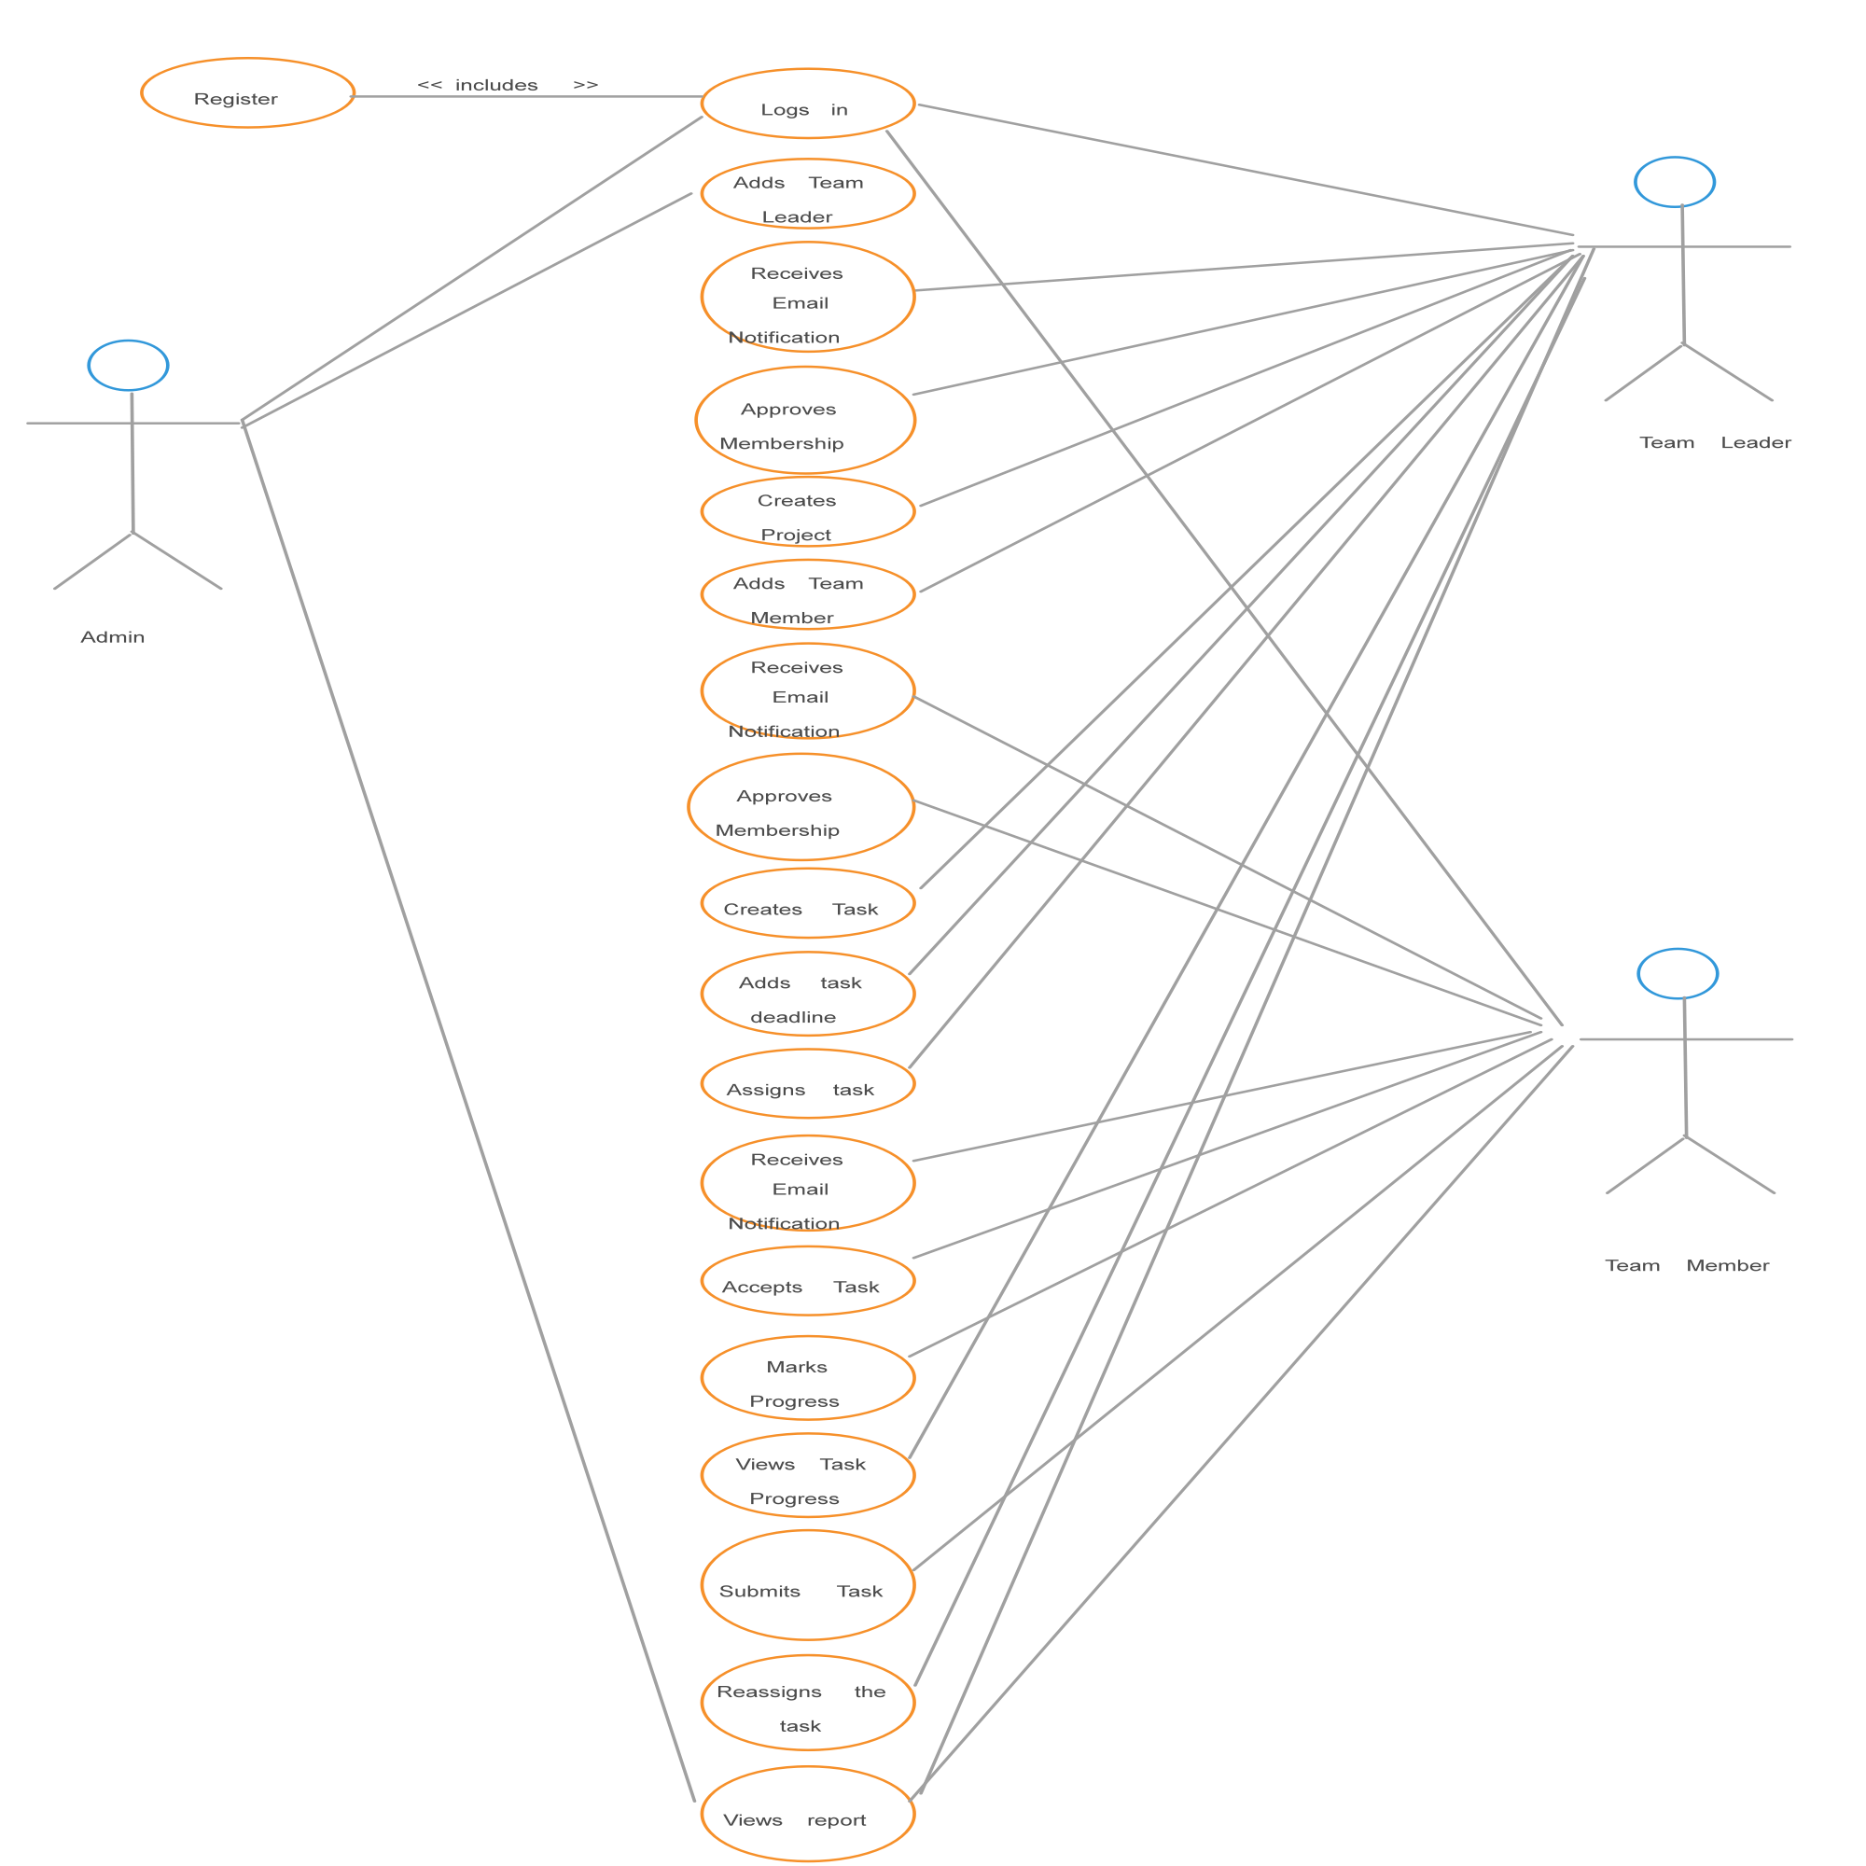

## The Task Management System (TMS) is envisioned as a standalone application that operates within the broader context of organizational workflow and project management. The system is designed to integrate seamlessly with existing tools and processes, enhancing task-related activities without imposing substantial changes to the overall organizational structure.

## Product Function

Entity Relationship Diagram of Task Management System



The Task Management System's entity relationship diagram (ERD) comprises key entities such as User, Task, Team, and Report. Users are associated with tasks through a many-to-many relationship, enabling assignment of multiple tasks to a user and vice versa. Tasks are linked to teams in a similar many-to-many relationship, allowing tasks to belong to one or more teams, and teams to handle multiple tasks. Users and Teams share a many-to-many relationship, facilitating membership of users in multiple teams and teams with multiple members. Additionally, Users and Teams are individually linked to Reports through one-to-many relationships, signifying that users can generate multiple reports, while each report is associated with a specific user or team. This ERD captures the core functionalities of the Task Management System, illustrating the relationships and cardinalities among entities to guide the system's database design.

## User Classes and Characteristics

The system distinguishes between two user types: Librarian and Member (comprising students and staff). The Librarian, serving as the controller with administrator privileges, has access to a set of features to efficiently manage the library. These features include issuing and returning books for members, viewing book categories and lists, managing the library's database by adding/editing book information, and accessing comprehensive reports on existing and issued books. Moreover, the Librarian can access student accounts, facilitating seamless library administration.Conversely, Members (students and staff) have a set of features tailored to their needs. They can view available book categories and lists, own a library account, check issued books, request new books, review their issuance history, and conduct specific book searches. This user-centrist functionality aims to enhance the online library experience for Members.In summary, the system provides a hierarchical access structure, empowering the Librarian with comprehensive administrative tools and Members with features catering to their library interactions. This segregation ensures efficient library management and a user-friendly experience for both administrators and members

.

## Operating Environment

The Task Management System (TMS) is designed to operate in the Windows environment and is accessible through popular web browsers such as Microsoft Internet Explorer 6.0 for legacy support, Google Chrome, and Mozilla Firefox. The system requires a stable internet connection for users to access its features, with optimized performance on Windows 7, 8, and 10. The TMS accommodates a range of client devices, including desktops, laptops, tablets, and smartphones, ensuring compatibility with varying hardware configurations such as a 15" color monitor and a 122-key keyboard. Browser compatibility is maintained across Internet Explorer, Chrome, and Firefox, with internet connectivity being the primary requirement for seamless access to this online product.

## Assumptions and Dependencies

The assumptions are:-

* + - Error-Free Coding: It is assumed that the development process will result in error-free code to ensure the system's reliability and functionality.The system should be user-friendly so that it is easy to use for the users
    - User-Friendly Interface:The TMS is expected to have a user-friendly interface to facilitate ease of use for all users, ensuring a positive experience.The system should have more storage capacity and provide fast access to the database
    - Database Accessibility:The information of users, tasks, and teams will be stored in a database accessible by the website, enabling efficient data management.The Library System is running 24 hours a day
    - Storage and Access Capacity: The system assumes ample storage capacity and swift access to the database to accommodate a growing volume of tasks and users.
    - User Authentication: Users must possess correct usernames and passwords to access their online accounts and perform actions within the system.

The dependencies are:-

* + - Hardware and Software Compatibility: The TMS relies on specific hardware and software configurations for its successful execution.On the basis of listing requirements and specification the project will be developed and run
    - Project Development Criteria: The project's development and runtime depend on adherence to the specified requirements and specifications.The system should have the general report stored
    - User Understanding: End users, particularly administrators, must have a proper understanding of the TMS to effectively utilize its features.

## Requirement

Software Configuration:-

The Task Management System (TMS) is developed using Java as the front end with support from Sun Microsystems and utilizes Microsoft SQL Server as the back end for database storage. The software is designed to operate on Windows NT, Windows 98, and Windows XP operating systems. The Java Runtime Environment (JRE) is required for execution, and NetBeans 7.0.1 serves as the Integrated Development Environment (IDE) for front-end development. The recommended hardware configuration includes a Pentium(R) Dual-core CPU, a 40GB hard disk, and a minimum of 256 MB RAM for optimal TMS performance. These software and hardware specifications ensure compatibility and efficiency, offering users a seamless experience with the TMS.

Hardware Configuration:- Processor: Pentium(R)Dual-core CPU Hard Disk: 40GB

RAM: 256 MB or more

## Data Requirement

The Task Management System (TMS) relies on a comprehensive set of data requirements to facilitate efficient task management and collaboration. User data encompasses unique identifiers, usernames, encrypted passwords, and roles such as Admin, Manager, or User. Task data includes identifiers, titles, descriptions, due dates, priorities, and statuses. Reporting data involves unique identifiers, report names, generation dates, and content. Notifications are managed through identifiers, sender and receiver user IDs, content, and timestamps. System configuration data encompasses parameters such as notification preferences and access controls, and log data tracks user actions with unique identifiers, user IDs, actions performed, and timestamps. Finally, team collaboration data involves identifiers, team IDs, and member user IDs. These requirements collectively form a structured data model essential for the seamless operation of the TMS, ensuring user authentication, task management, reporting, notifications, system configuration, and collaborative team interactions.

# External Interface Requirement

## GUI

The software provides good graphical interface for the user and the administrator can operate on the system, performing the required task such as create, update, viewing the details of the book.

* + - It allows user to view quick reports like Book Issued/Returned in between particular time.
    - It provides stock verification and search facility based on different criteria.
    - The user interface must be customization by the administrator
    - All the modules provided with the software must fit into this graphical user interface and accomplish to the standard defined
    - The design should be simple and all the different interfaces should follow a standard

template

* + - The user interface should be able to interact with the user management module and a part of the interface must be dedicated to the login/logout module

Login Interface:-

User Registration:

- New users can register by entering their details to create an account.

Login:

- Existing users can log in by entering their username and password.

- Error handling: In case of incorrect entries, error messages are displayed to guide users.

Search:-

The member or librarian can enter the type of book he is looking for and the title he is interested in,then he can search for the required book by entering the book name.

Categories View:-

Categories view shows the categories of books available and provides ability to the librarian to add/edit or delete category from the list.

Librarian’s Control Panel:-

This control panel will allow librarian to add/remove users; add, edit, or remove a resource. And manage lending options.

# System Features

# The Task Management System (TMS) incorporates crucial features to ensure user security and effective system monitoring. Unique member ID authentication and validation guarantee the security of user accounts. Administrators possess the ability to monitor and update account statuses, issue pop-up notifications for members exceeding book issuance limits, and assign fines for late returns, thereby enforcing library policies. The system maintains proper accountability by restricting member access to other accounts, reserving such privileges exclusively for administrators. These features collectively establish a secure and accountable environment within the TMS, fostering efficient task management.Other Non-functional Requirements

## Performance Requirement:

## The proposed Task Management System (TMS) is intended to serve as the primary performance system across various university campuses, engaging with university staff and students. The database is expected to fulfill all specified university requirements, emphasizing fast and accurate system performance. In the context of potential errors, the TMS, like the Library Management System, is designed to handle both expected and unexpected errors efficiently, preventing information loss and minimizing downtime. The system is engineered to incorporate robust error testing mechanisms, including the identification of invalid usernames/passwords. Moreover, the TMS is built to handle substantial volumes of data, accommodating a high number of tasks and users seamlessly, ensuring faultless operation.Safety Requirement

The database may get crashed at any certain time due to virus or operating system failure. Therefore, it is required to take the database backup so that the database is not lost. Proper UPS/inverter facility should be there in case of power supply failure.

## Security Requirement

* + - System will use secured database
    - Normal users can just read information but they cannot edit or modify anything except their personal and some other information.
    - System will have different types of users and every user has access constraints
    - Proper user authentication should be provided
    - No one should be able to hack users’ password
    - There should be separate accounts for admin and members such that no member can access the database and only admin has the rights to update the database.

## Requirement attributes

* + - There may be multiple admins creating the project, all of them will have the right to create changes to the system. But the members or other users cannot do changes
    - The project should be open source
    - The Quality of the database is maintained in such a way so that it can be very user friendly to all the users of the database
    - The user be able to easily download and install the system

## Business Rules

A business rule is anything that captures and implements business policies and practices. A rule can enforce business policy, make a decision, or infer new data from existing data.This includes the rules and regulations that the System users should abide by. This includes the cost of the project and the discount offers provided. The users should avoid illegal rules and protocols. Neither admin nor member should cross the rules and regulations.

## User Requirement

The users of the system are members and Librarian of the university who act as administrator to maintain the system. The members are assumed to have basic knowledge of the computers and internet browsing. The administrators of the system should have more knowledge of the internals of the system and is able to rectify the small problems that may arise due to disk crashes, power failures and other catastrophes to maintain the system. The proper user interface, user manual, online help and the guide to install and maintain the system must be sufficient to educate the users on how to use the system without any problems.

The admin provides certain facilities to the users in the form of:-

* + - Backup and Recovery
    - Forgot Password
    - Data migration i.e. whenever user registers for the first time then the data is stored in the server
    - Data replication i.e. if the data is lost in one branch, it is still stored with the server
    - Auto Recovery i.e. frequently auto saving the information
    - Maintaining files i.e. File Organization
    - The server must be maintained regularly and it has to be updated from time to time

# Other Requirements

## Data and Category Requirement

The Task Management System (TMS) incorporates distinct user categories, including teaching staff, administrators, librarians, and students, each assigned specific access rights based on their roles. Administrators possess comprehensive rights to modify, delete, and append data, while other users, excluding librarians, are restricted to retrieving database information. Additionally, the TMS accommodates various categories of tasks, and the relevant data associated with each category is systematically organized. The coding format ensures that information related to different task categories is appropriately displayed and managed within the system, facilitating efficient task management based on user roles and task categories.

## Appendix

A: Admin, Abbreviation, Acronym, Assumptions; B: Books, Business rules; C: Class, Client, Conventions; D: Data requirement, Dependencies; G: GUI; K: Key; L: Library, Librarian; M: Member; N: Non-functional Requirement; O: Operating environment; P: Performance,Perspective,Purpose; R: Requirement, Requirement attributes; S: Safety, Scope, Security, System features; U: User, User class and characteristics, User requirement;

## Glossary

The following are the list of conventions and acronyms used in this document and the project as well:

* + - Administrator: A login id representing a user with user administration privileges to the software
    - User: A general login id assigned to most users
    - Client: Intended users for the software
    - SQL: Structured Query Language; used to retrieve information from a database
    - SQL Server: A server used to store data in an organized format
    - Layer: Represents a section of the project
    - User Interface Layer: The section of the assignment referring to what the user interacts with directly
    - Application Logic Layer: The section of the assignment referring to the Web Server. This is where all computations are completed
    - Data Storage Layer: The section of the assignment referring to where all data is recorded
    - Use Case: A broad level diagram of the project showing a basic overview
    - Class diagram: It is a type of static structure diagram that describes the structure of a system by showing the system’s cases, their attributes, and the relationships between the classes
    - Interface: Something used to communicate across different mediums
    - Unique Key: Used to differentiate entries in a database

## Class Diagram

In the Task Management System (TMS), a class serves as an abstract and user-defined representation of a data type, delineating its attributes and the permissible operations on instances or objects of that data type. Each class is identified by a name and comprises a set of attributes defining its characteristics, along with a set of operations applicable to its objects. The static model of classes, including their structure and interrelationships, is vital for understanding the system.

In the TMS project, key classes, such as 'Task,' 'User,' and 'Team,' are essential for the system's functionality. These classes have interrelated dependencies depicted through various relationships, including normal associations, aggregations, and generalizations, which are illustrated in the diagram. Notably, the 'Task,' 'User,' and 'Team' classes are pivotal, serving as core entities that interact with other classes to facilitate seamless task management within the system. The relationships are articulated through role names and multiplicities, providing a comprehensive understanding of the dynamic interactions between classes in the TMS.

